MATLAB PROBLEM SHEET -3

19pw13-Madhumitha.S

1.

>> x = [1 2 3 4 5 6 7 8 9 10]

x =

1 2 3 4 5 6 7 8 9 10

>> y = [2 5 6 7 8 10 13 15 18 19]

y =

2 5 6 7 8 10 13 15 18 19

>> plot (x, y)

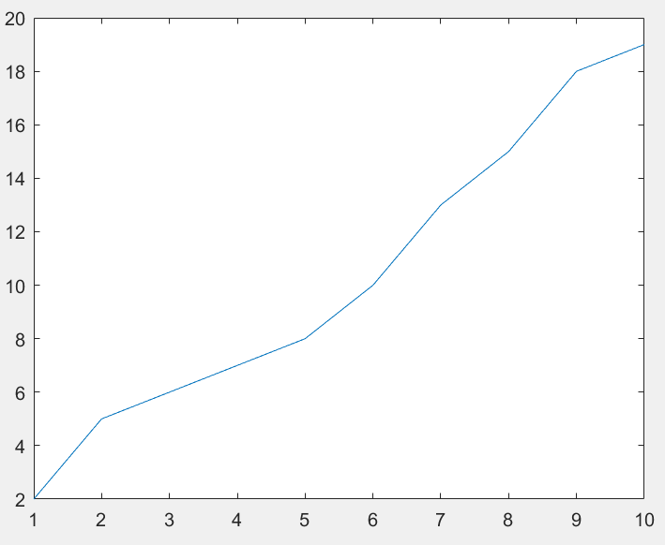

2.

>>plot(x,y,'--or','Linewidth',2,'MarkerSize',12,'MarkerEdgeColor','g','MarkerFaceColor','y')

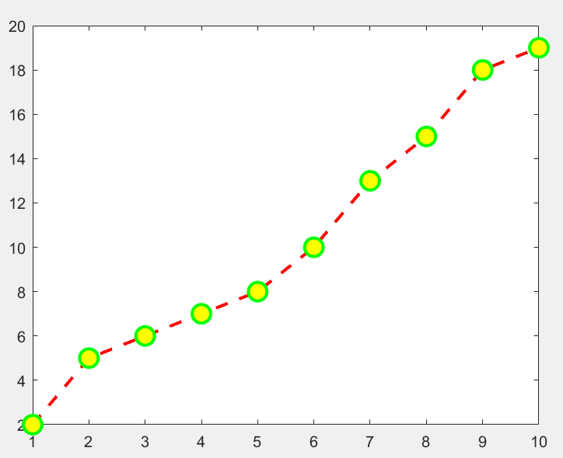

3.

>>X = -2:0.01:4

X =

Columns 1 through 6

-2.0000 -1.9900 -1.9800 -1.9700 -1.9600 -1.9500

…………………

…………………

Columns 595 through 600

3.9400 3.9500 3.9600 3.9700 3.9800 3.9900

Column 601

4.0000

>> fplot(@(x)(3.5.^-0.5.*x).*cos(6.*x),[-2,4])

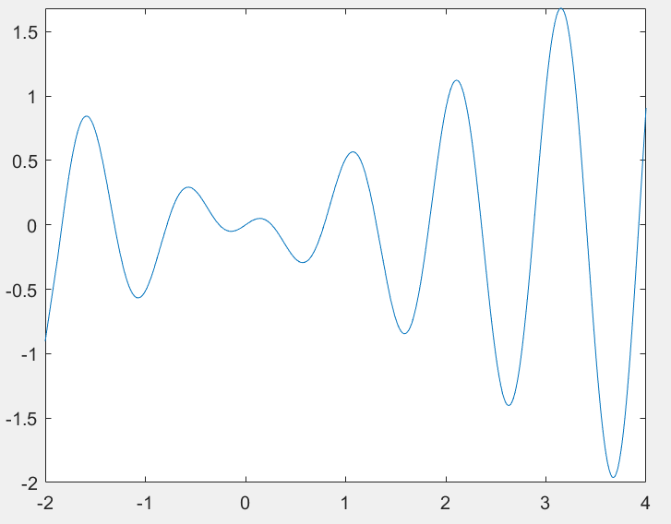

4.

(a) >> fplot(@(x)x.^2, [1,10])

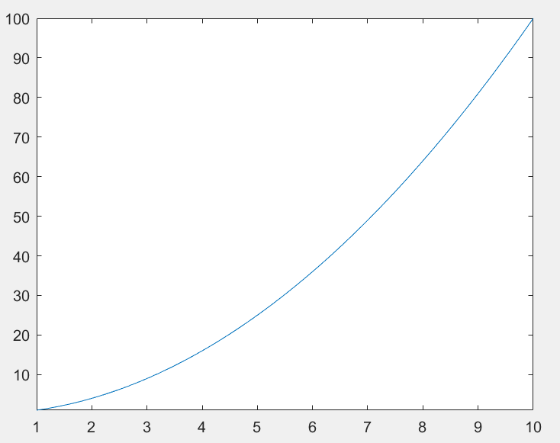

(b)>> fplot(@(x)x.^3, [1,10])

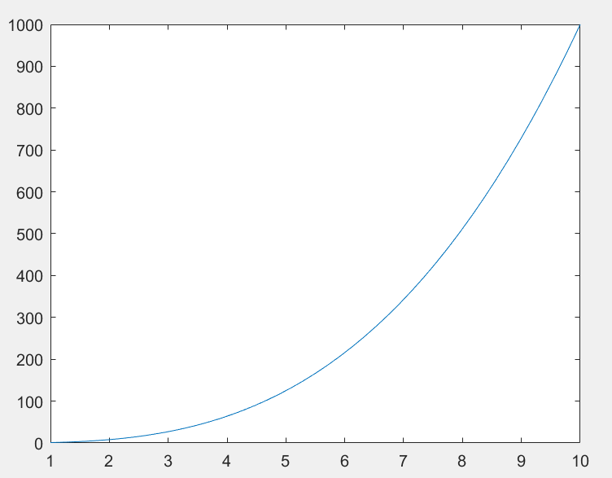

(c)

>> fplot(@(x)log(x),[1,10])

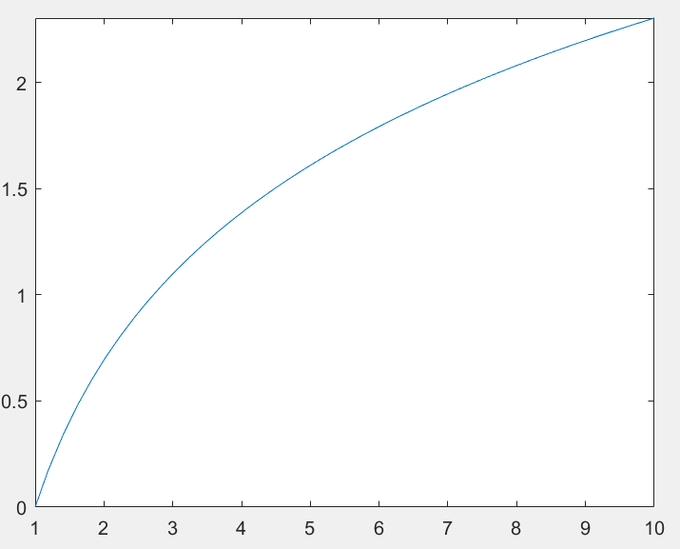

(d)

>> fplot(@(x)1./x,[1,10])

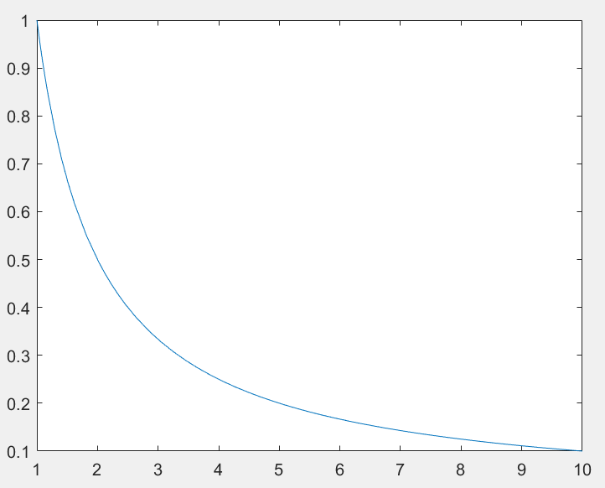

5.

(a) >> fplot(@(x)sin(x),[0,2*pi])

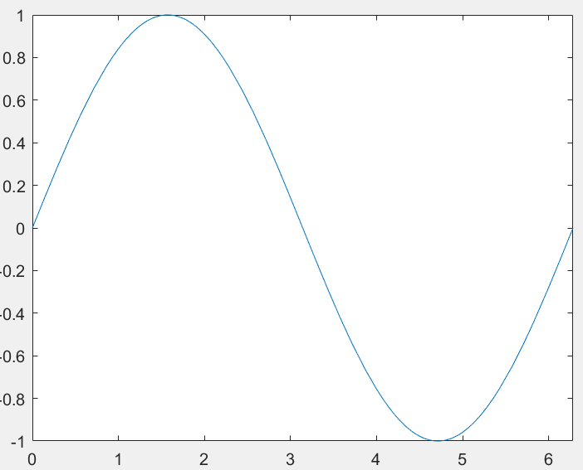

(b)>> fplot(@(x)cos(x),[0,2*pi])

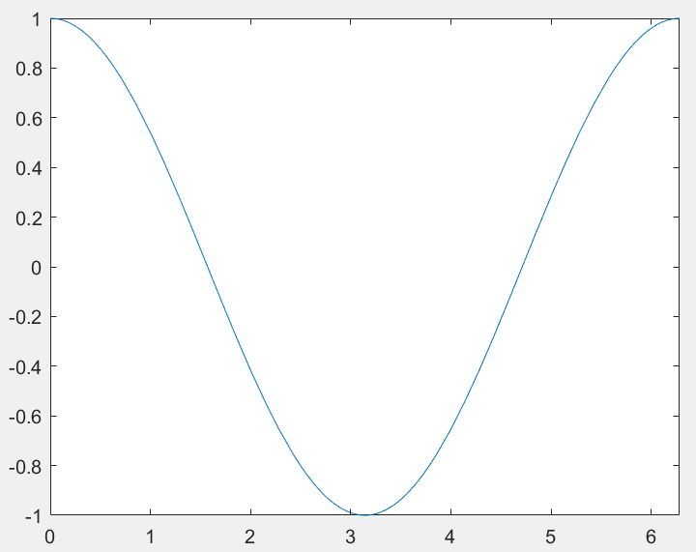

(c)>> fplot(@(x)tan(x),[0,2*pi])

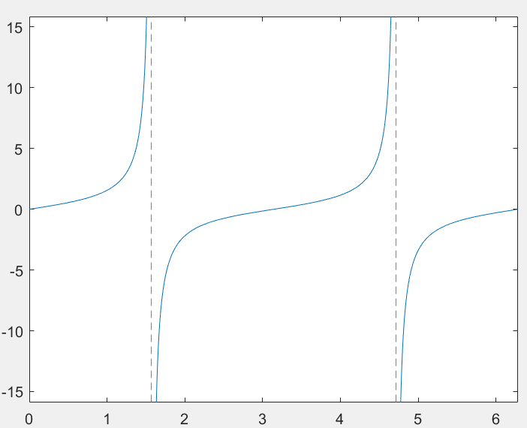

6.

>> fplot(@(x)(x+5).^2./(4+3.*x.^2),[-3,5])

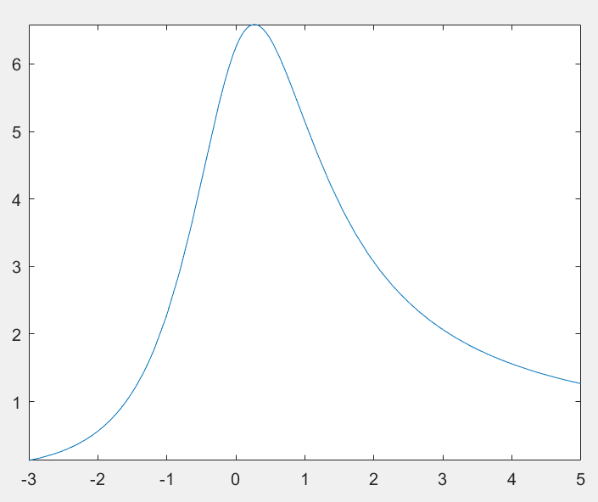

7.

>>x=[-2:4];

y=3*x.^3 - 26*x + 10;

yd=9*x.^2 - 26;

ydd=18*x;

plot(x,y,x,yd,x,ydd)

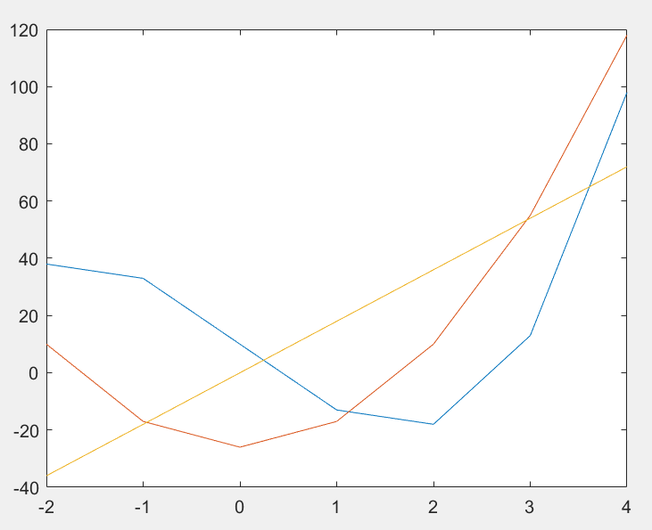

8.

>> plot(x,y)

>> hold on

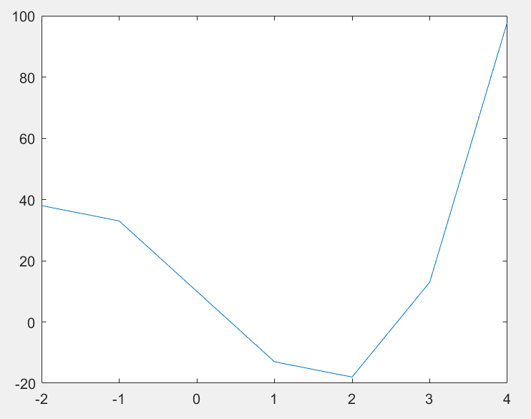

>> plot(x,yd)

>> hold on

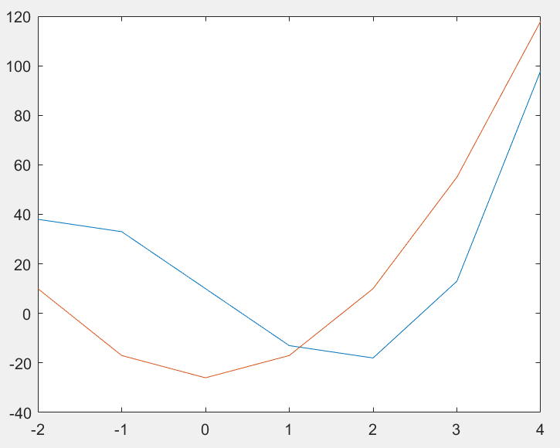

>> plot(x,ydd)

>> hold off



9.

>>line(x,y);

line(x,yd,'Color','red');

line(x,ydd,'Color','green')

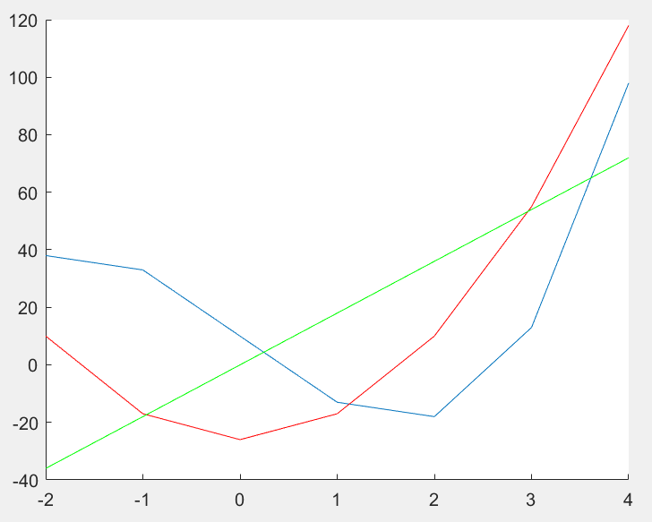

10.

>>x=[10:0.1:22];

y=95000./x.^2;

xd=linspace(10,22,7);

yd=[950 640 460 340 250 180 140]

plot(x,y,'LineWidth',2)

xlabel('Distance (cm)');

ylabel('Intensity (flux)');

title('\fontname{Arial}Light Intensity as a Function of Distance')

axis([8,24,0,1200])

text(14,700,'Comparison between experiment and theory','EdgeColor','r','LineWidth',2)

hold on

plot(xd,yd,'ro--','LineWidth',1,'MarkerSize',10)

legend('Theory','Experiment')

hold off

yd =

950 640 460 340 250 180 140

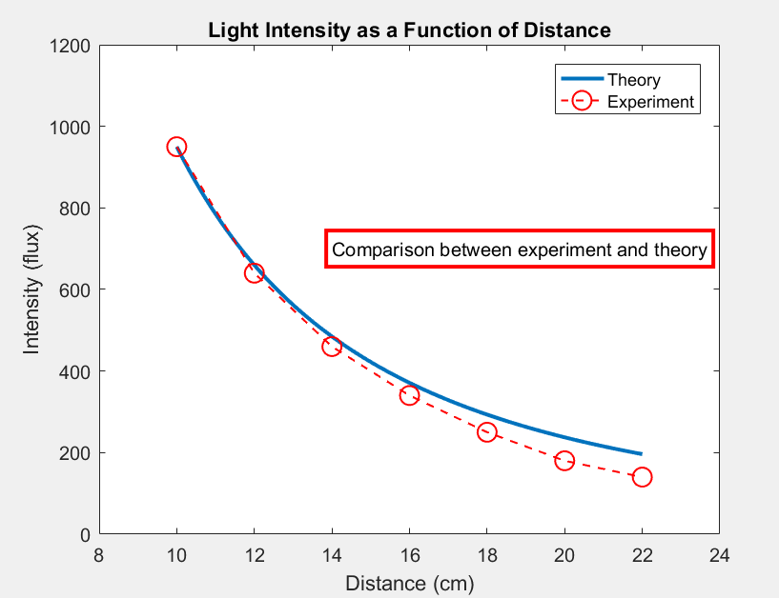

11.

>>x = linspace(0,100);

y1 = x.^2;

y2 = x.^3;

y3=log(x)

y4=1./x

subplot(4,1,1);

plot(x,y1)

subplot(4,1,2);

plot(x,y2)

subplot(4,1,3)

plot(x,y3)

subplot(4,1,4)

plot(x,y4)

**ans:**

y3 =

Columns 1 through 6

-Inf 0.0101 0.7032 1.1087 1.3963 1.6195

Columns 7 through 12

……………………………………..

………………………………………

Columns 97 through 100

4.5744 4.5848 4.5950 4.6052

y4 =

Columns 1 through 6

Inf 0.9900 0.4950 0.3300 0.2475 0.1980

Columns 7 through 12

……………………………………..

………………………………………

Columns 97 through 100

0.0103 0.0102 0.0101 0.0100

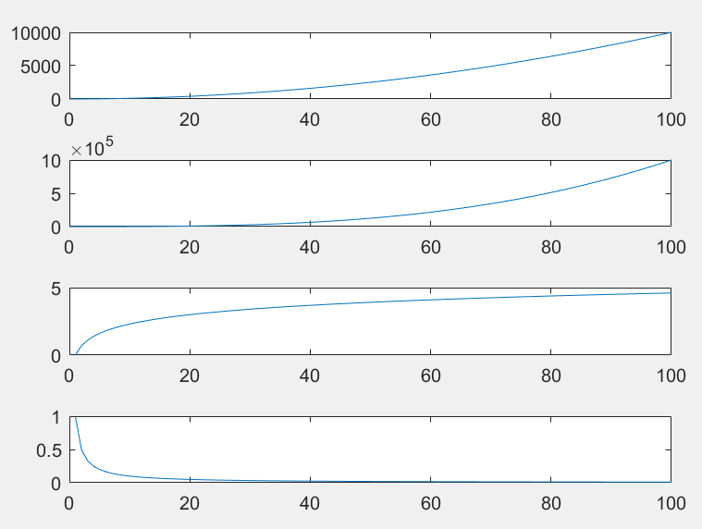

12.

>>figure

fplot(@(x)(x+1).*(x-2).*(2.*x-0.25)-exp(x),[0,3])

figure

fplot(@(x)(x+1).*(x-2).*(2.*x-0.25)-exp(x),[-3,6])

